**TASK🡪EBS-Backup**

Step 1🡪we need to be create RHEL8 Instance

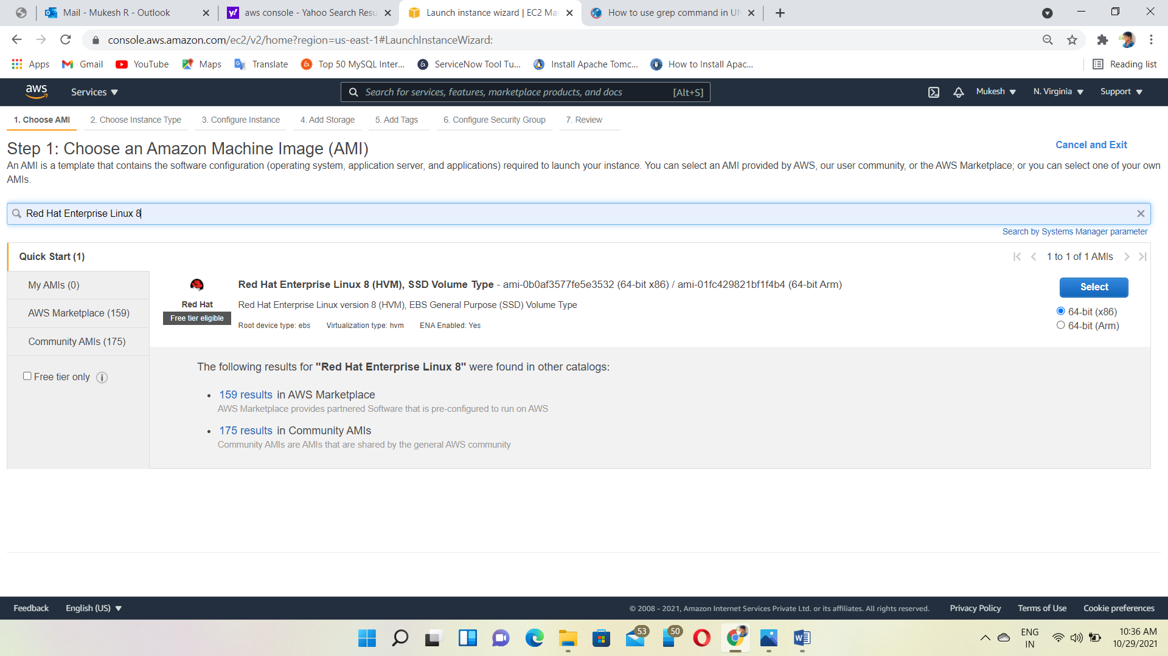

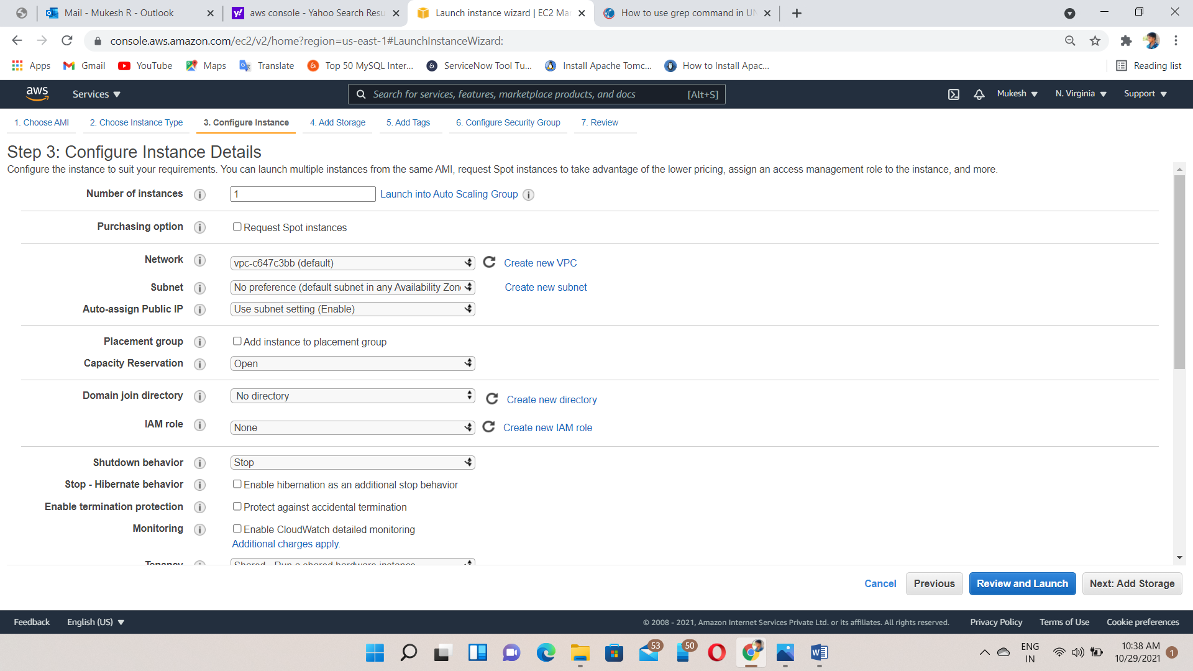

Allow All traffic

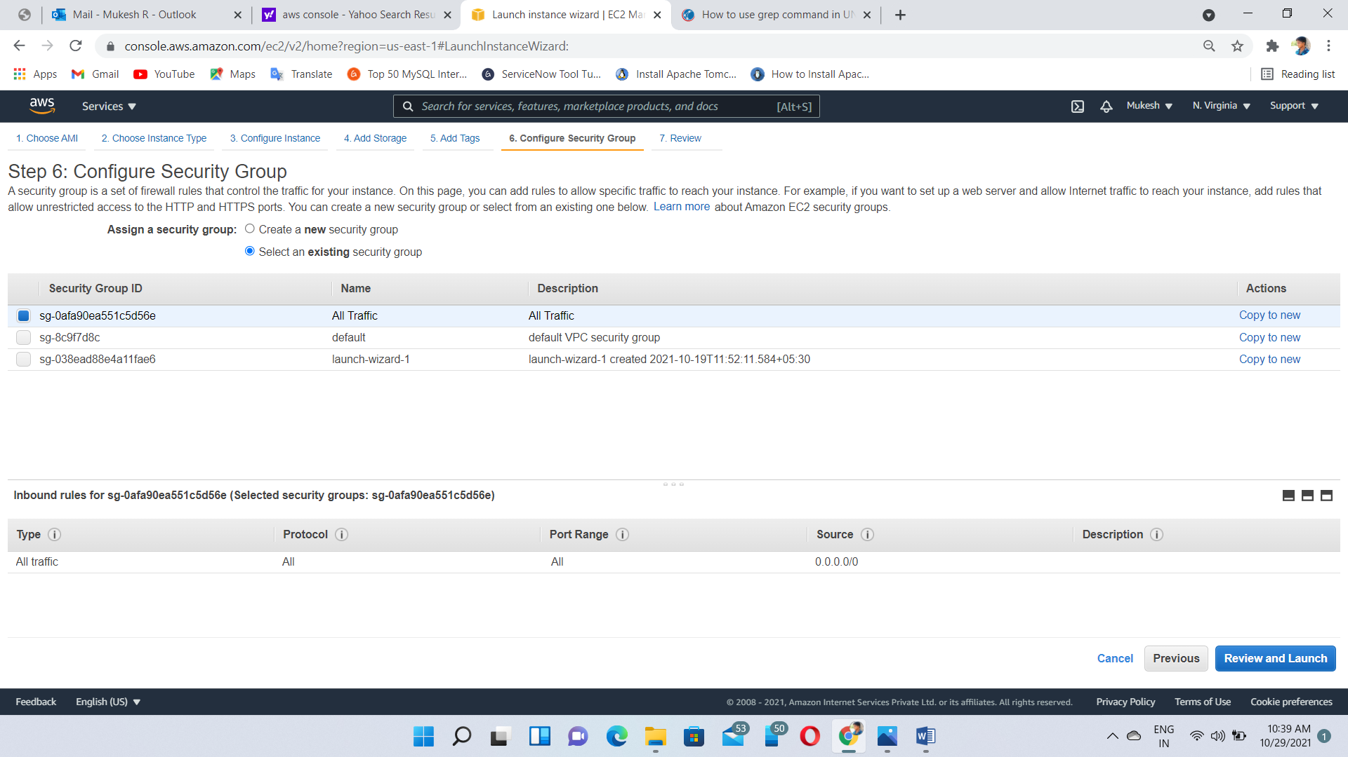

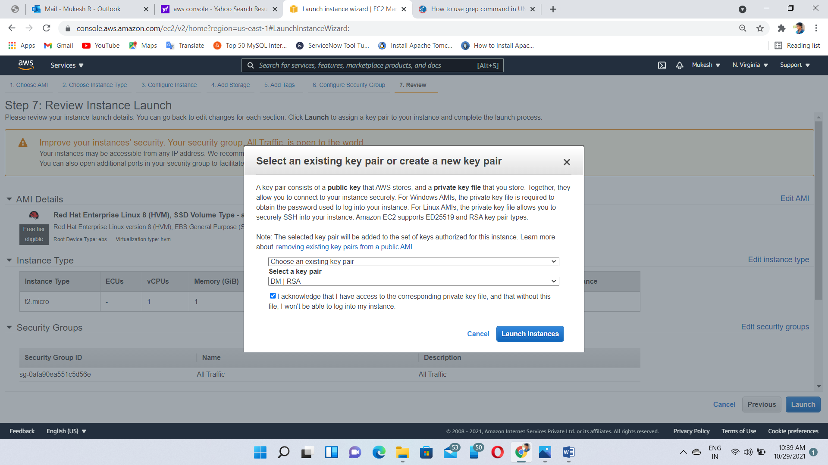

Step 2🡪To be create New Volume

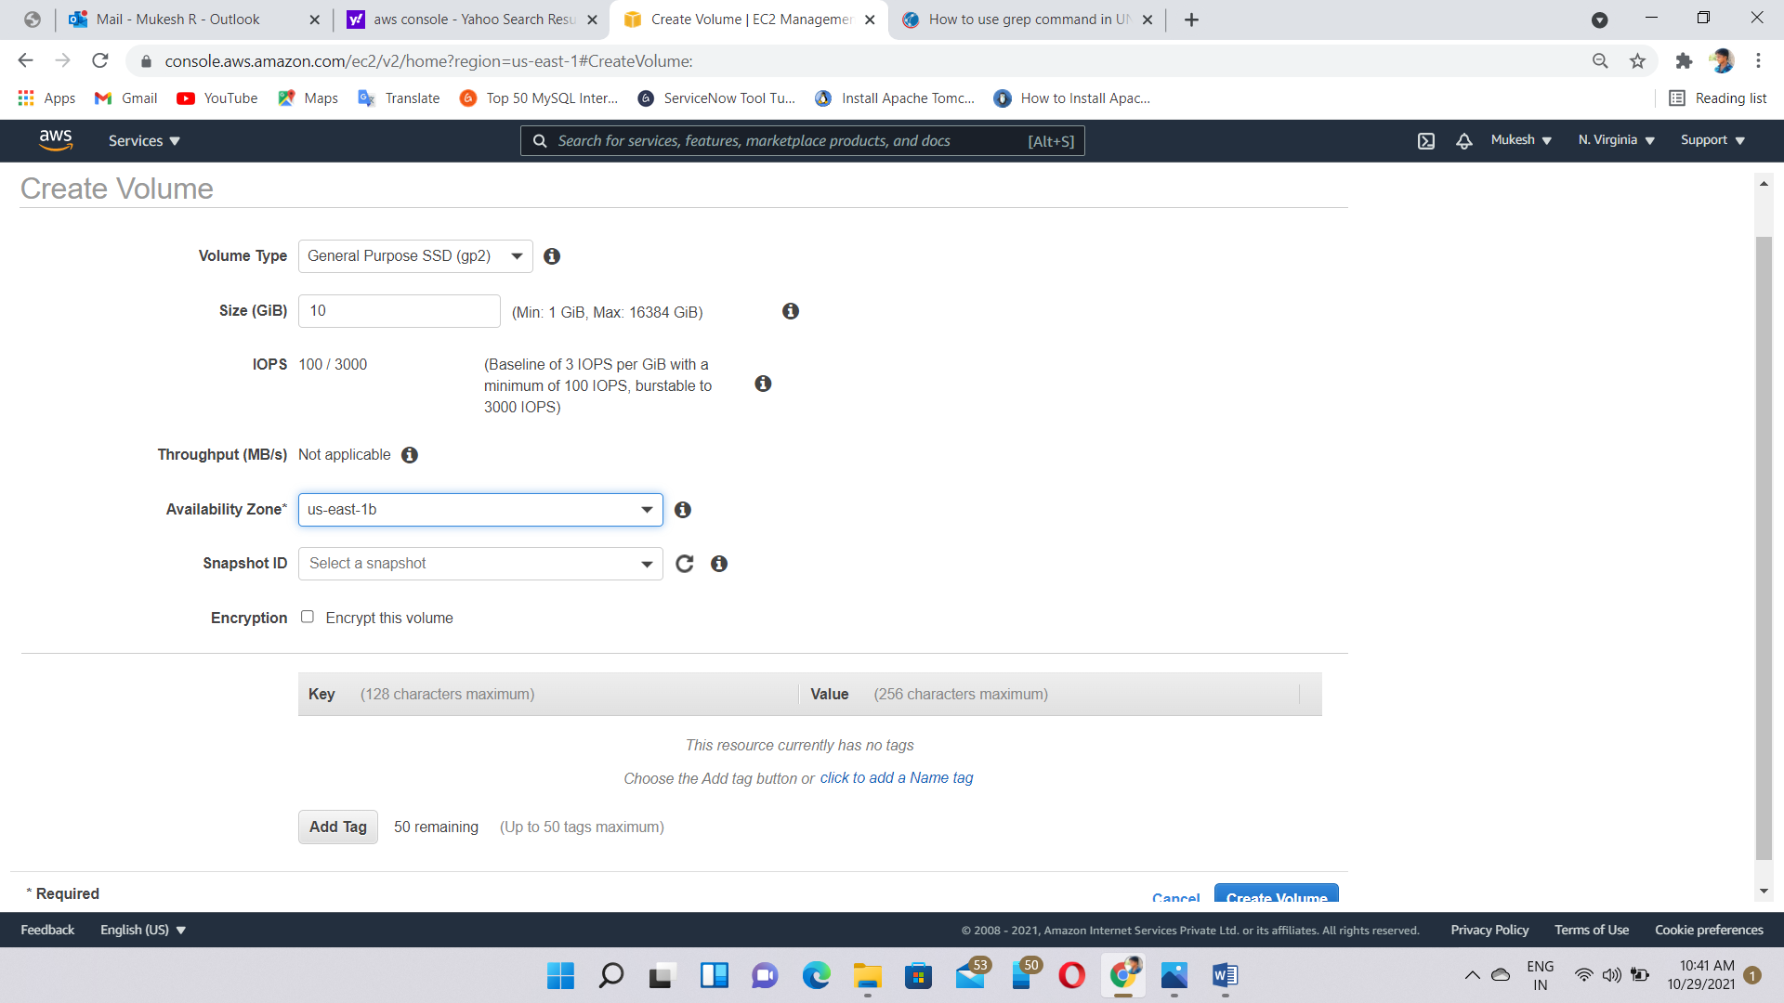

Step 3🡪Attach volume to the Instance

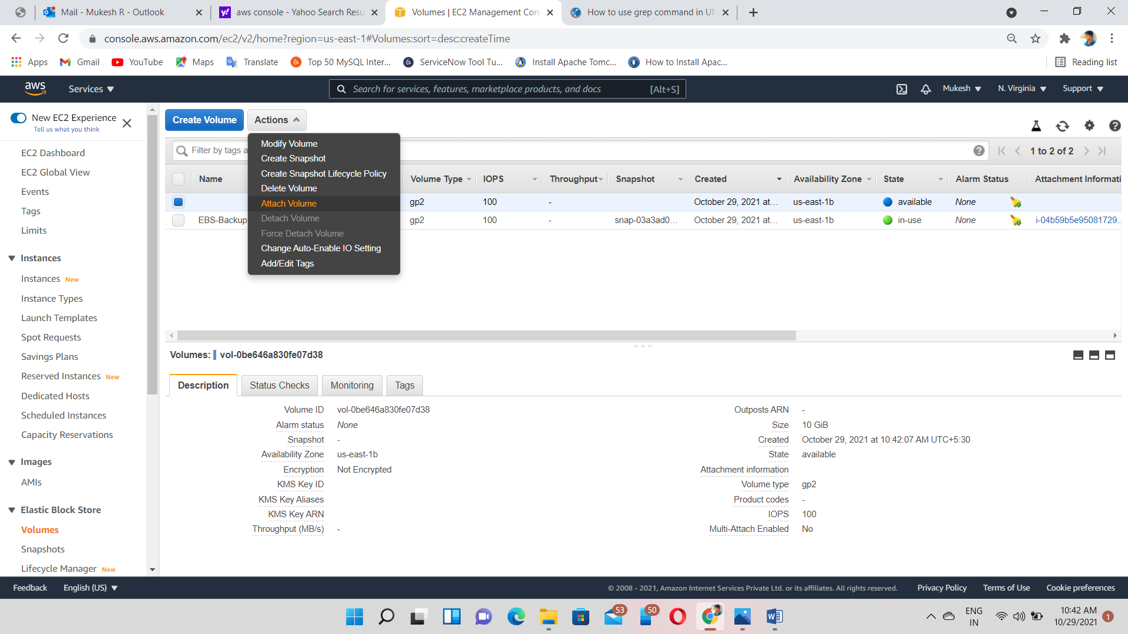

Attached

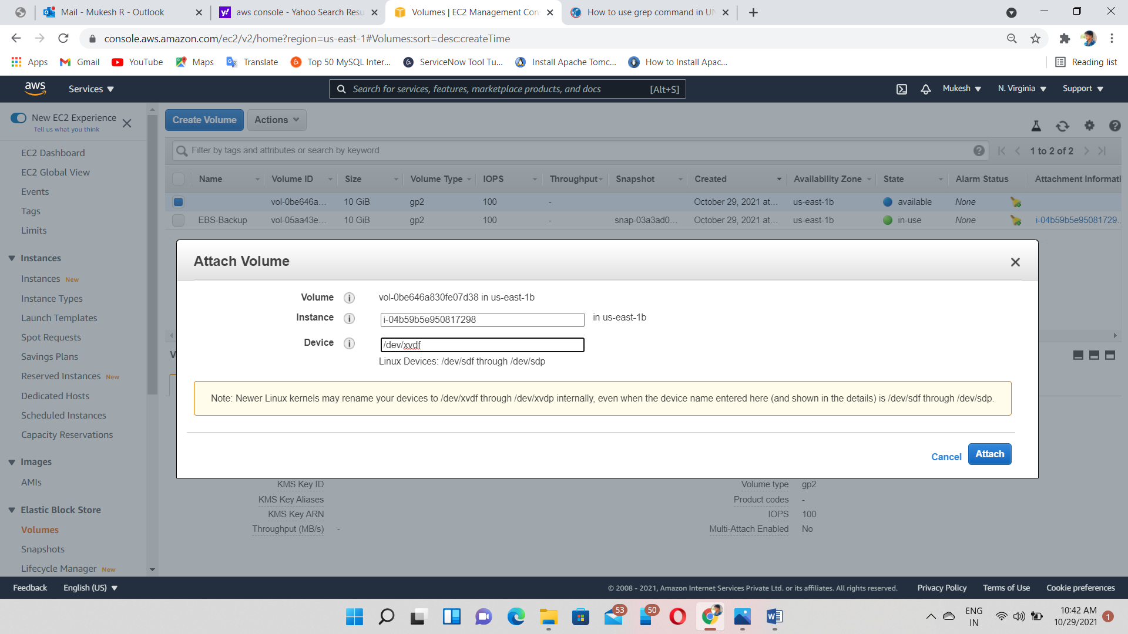

Step 3🡪Login to the instance via putty

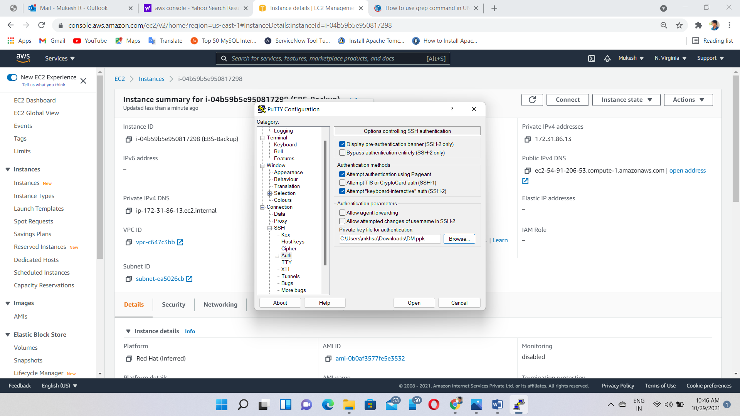

Step 4🡪Commands

Lsblk—check & view the volume blocks

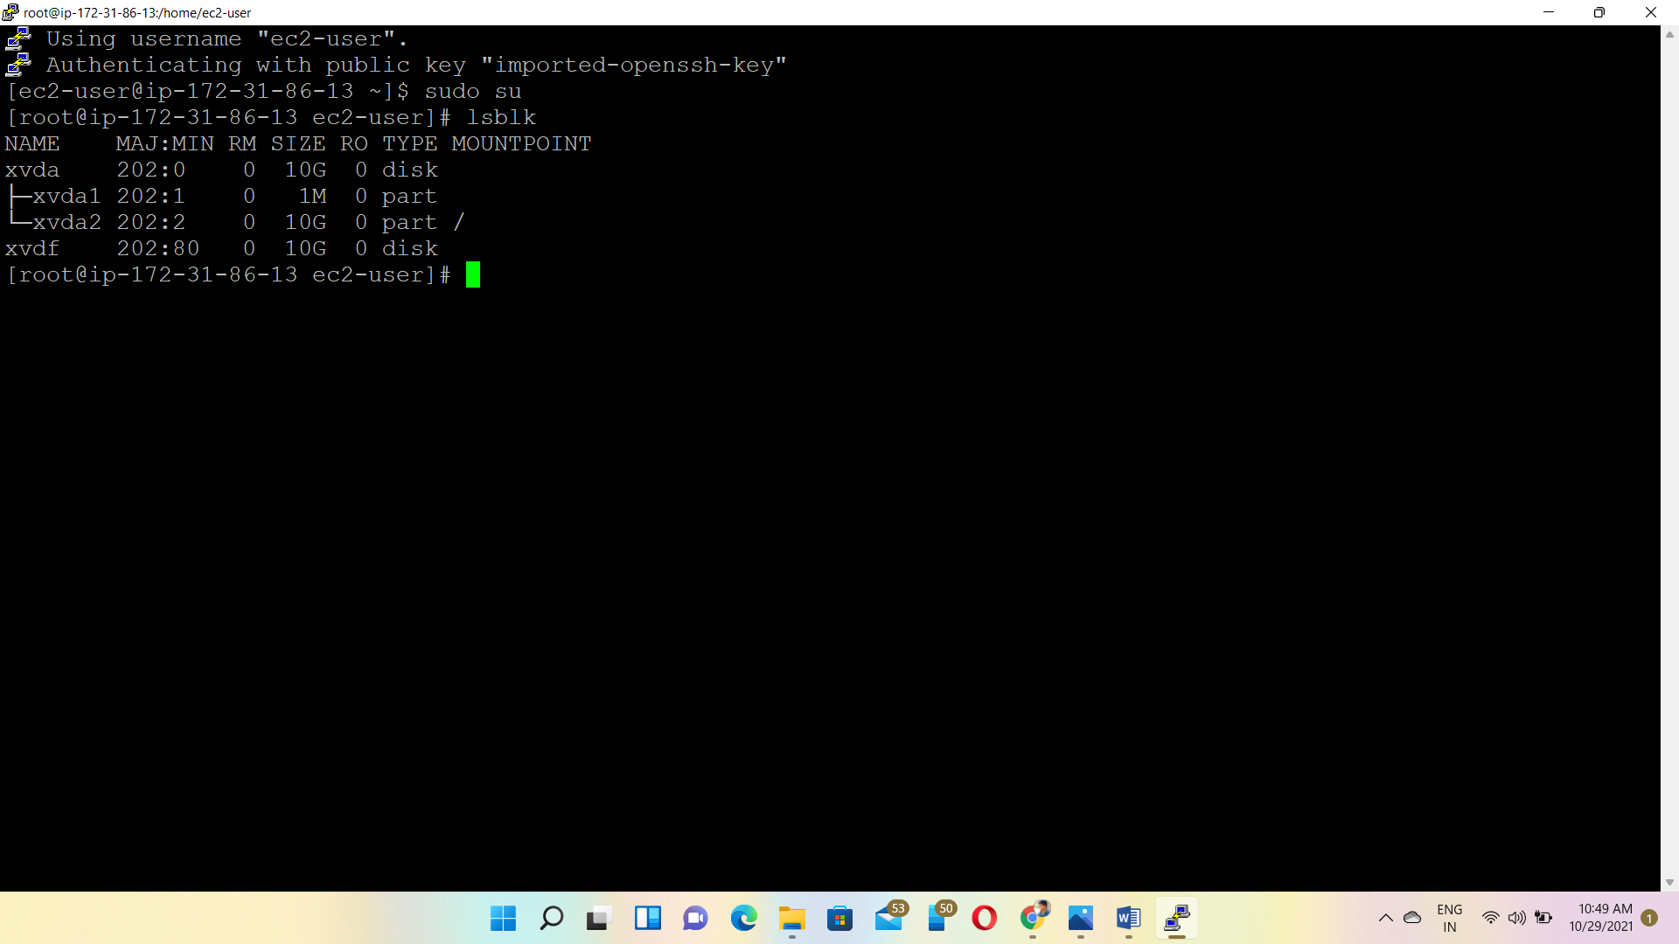

Fdisk /dev/xvdf--Create partitions

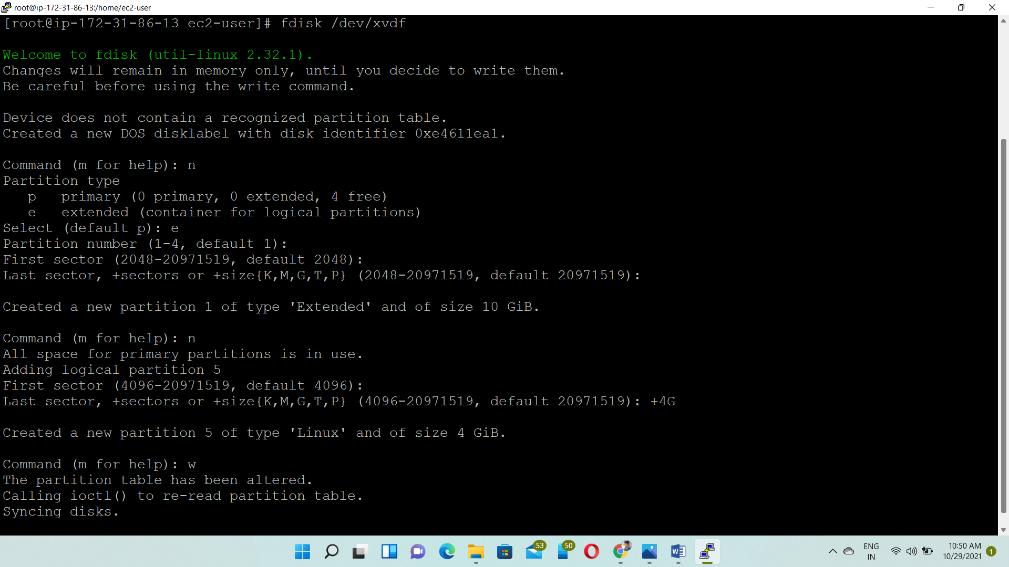

Mkfs.ext4 /dev/xvdf5 –format the partitions

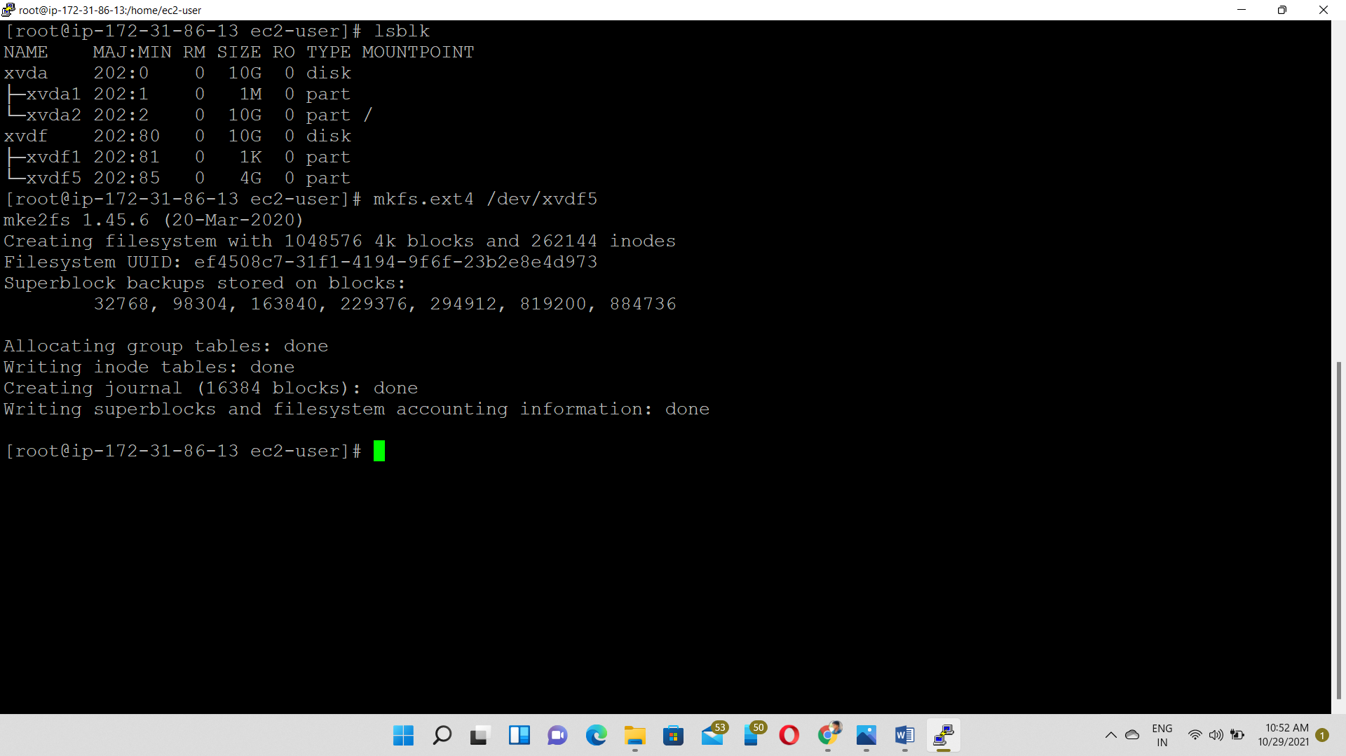

Step 5 🡪 Mount the Partitions

Mount /dev/xvdf5 /mount1—mounting /dev/xvdf5 volume to the /mount1 directory.

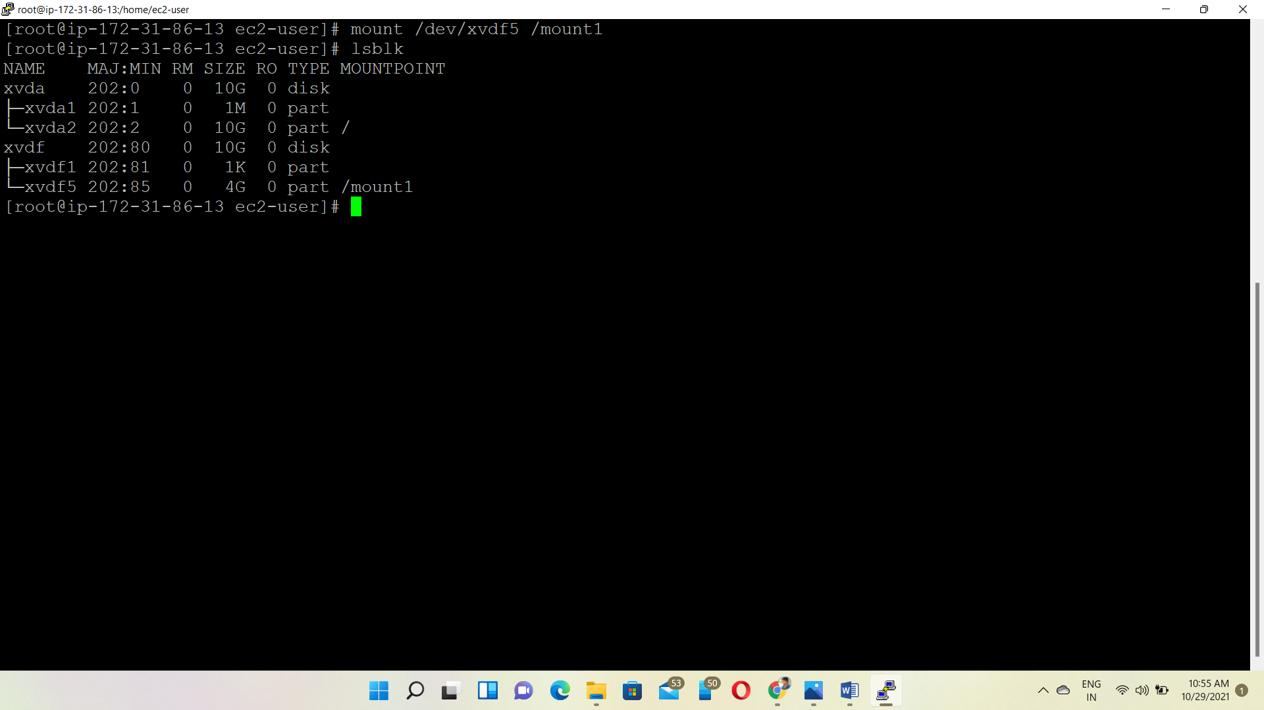

Inserting the data to the /mount1 directory

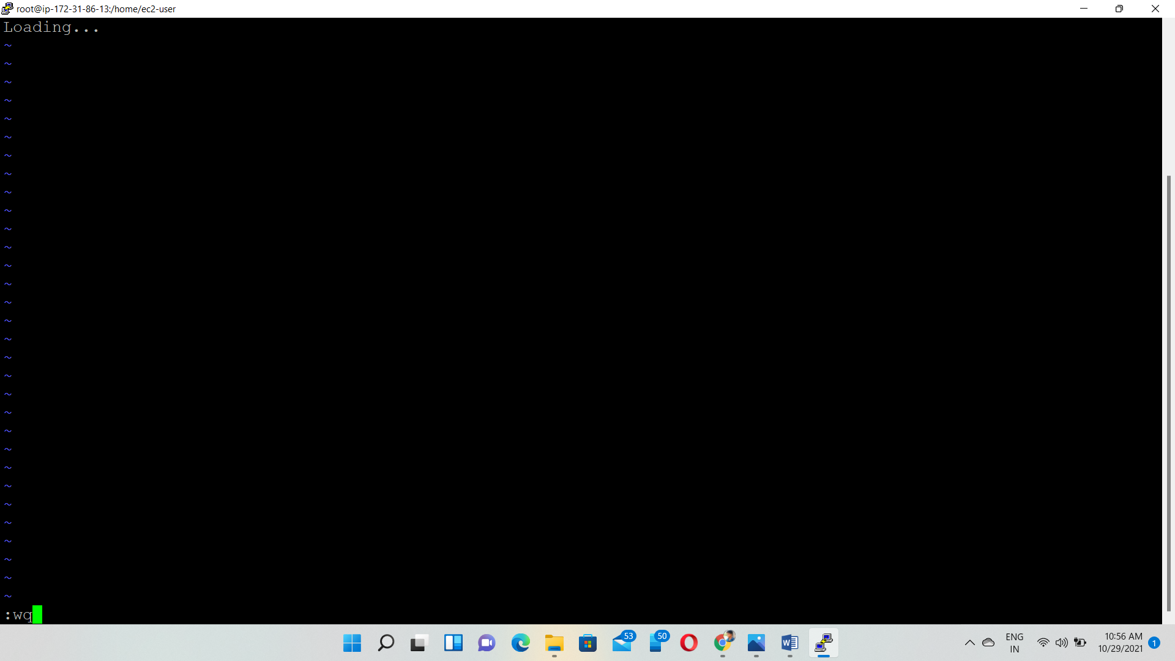

View the data from the directory

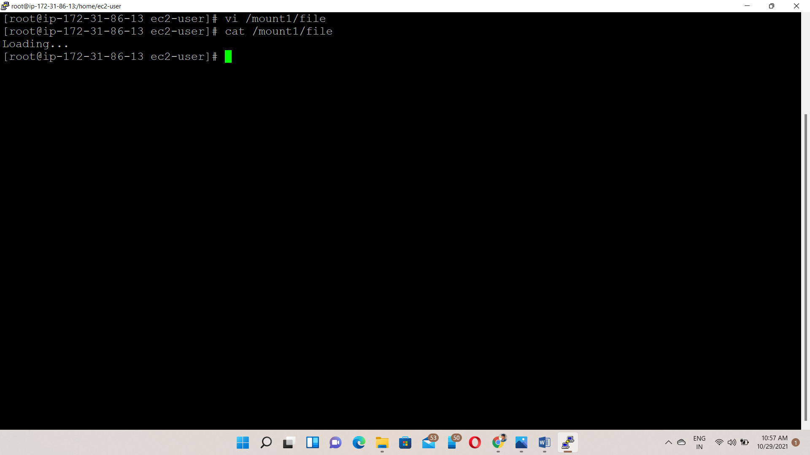

Step 6🡪Backup

Create snapshot from the volume

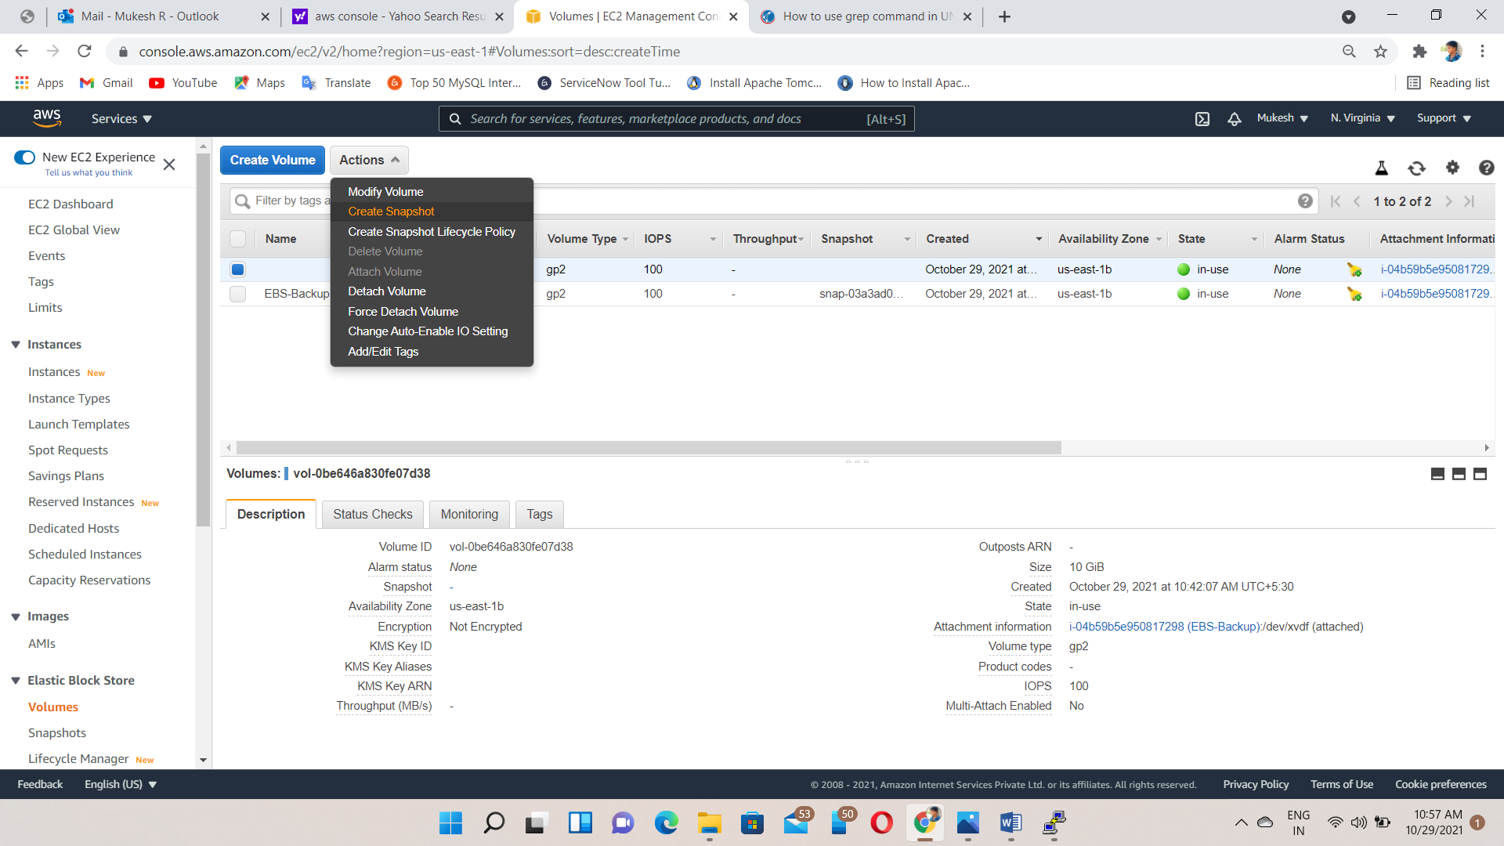

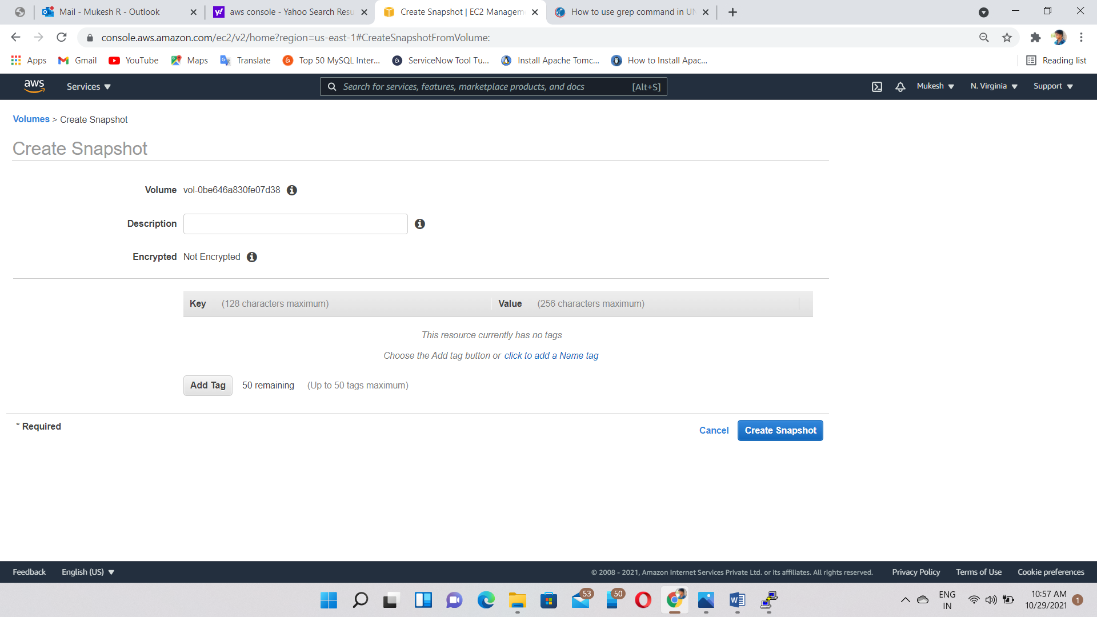

Creating the volume from the snapshot

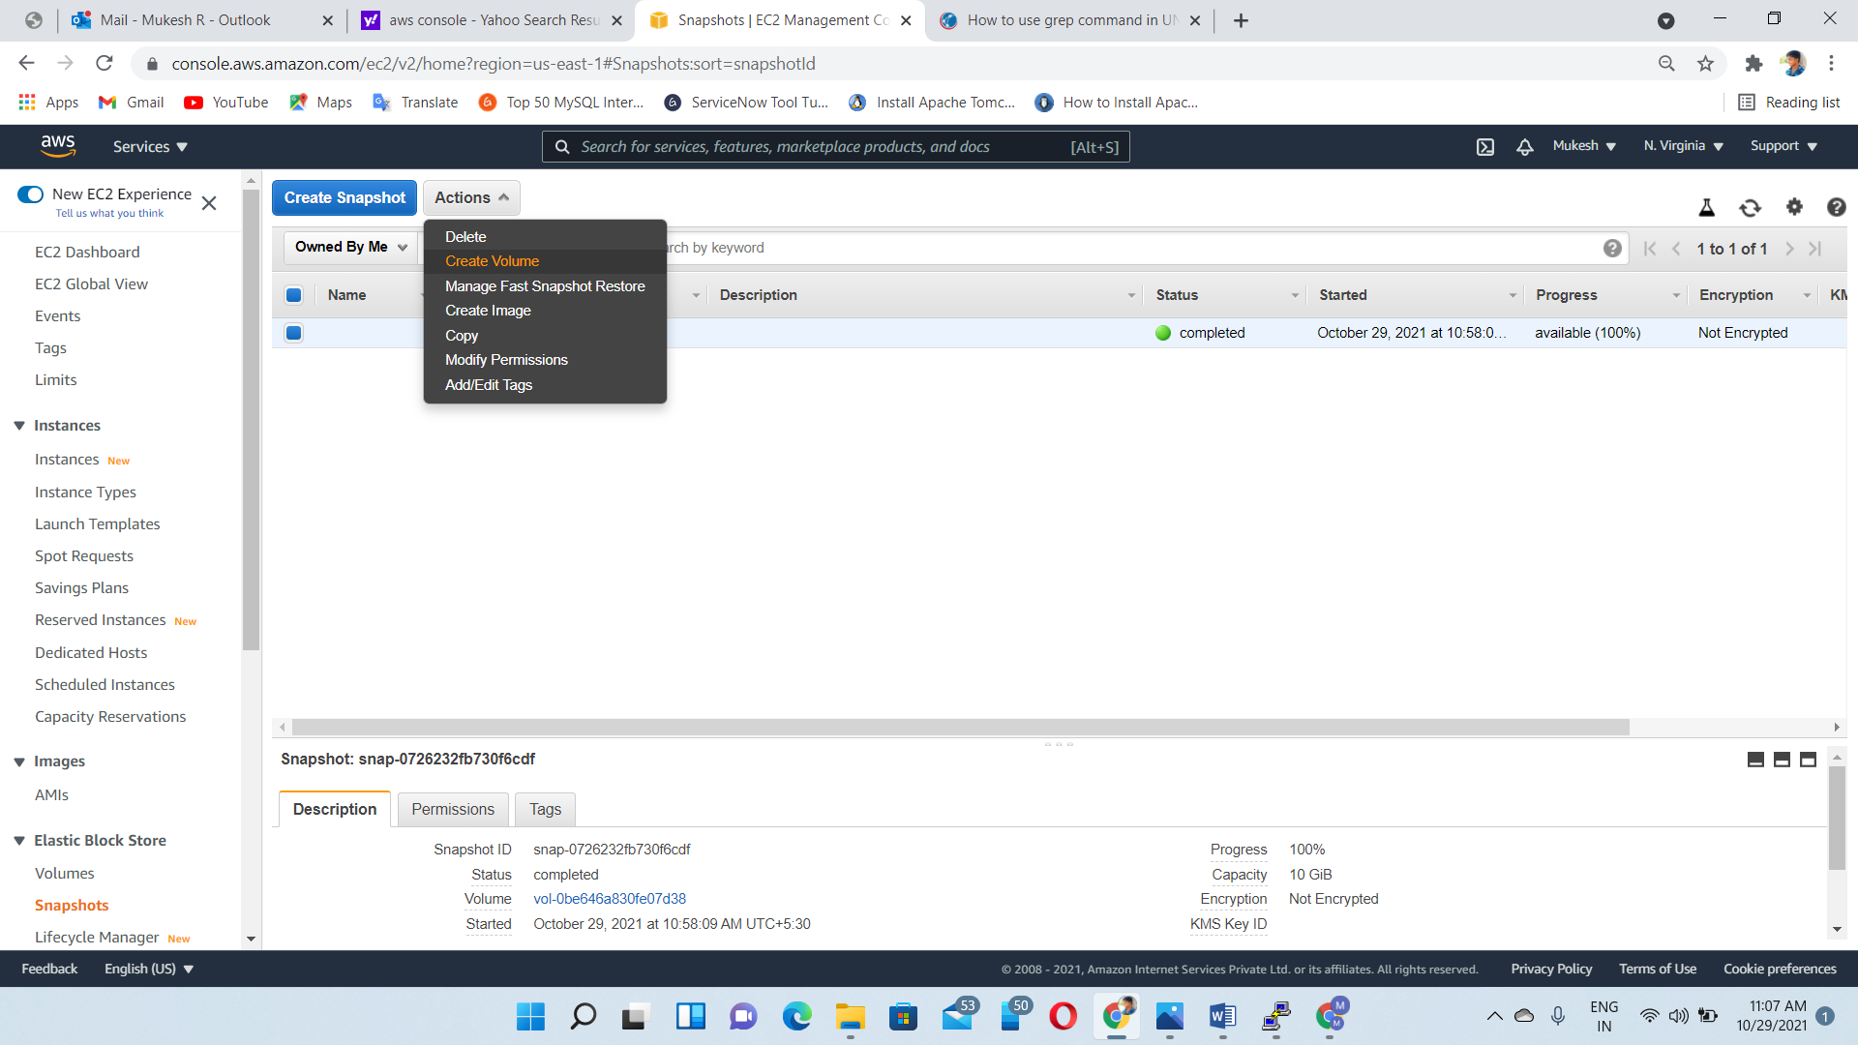

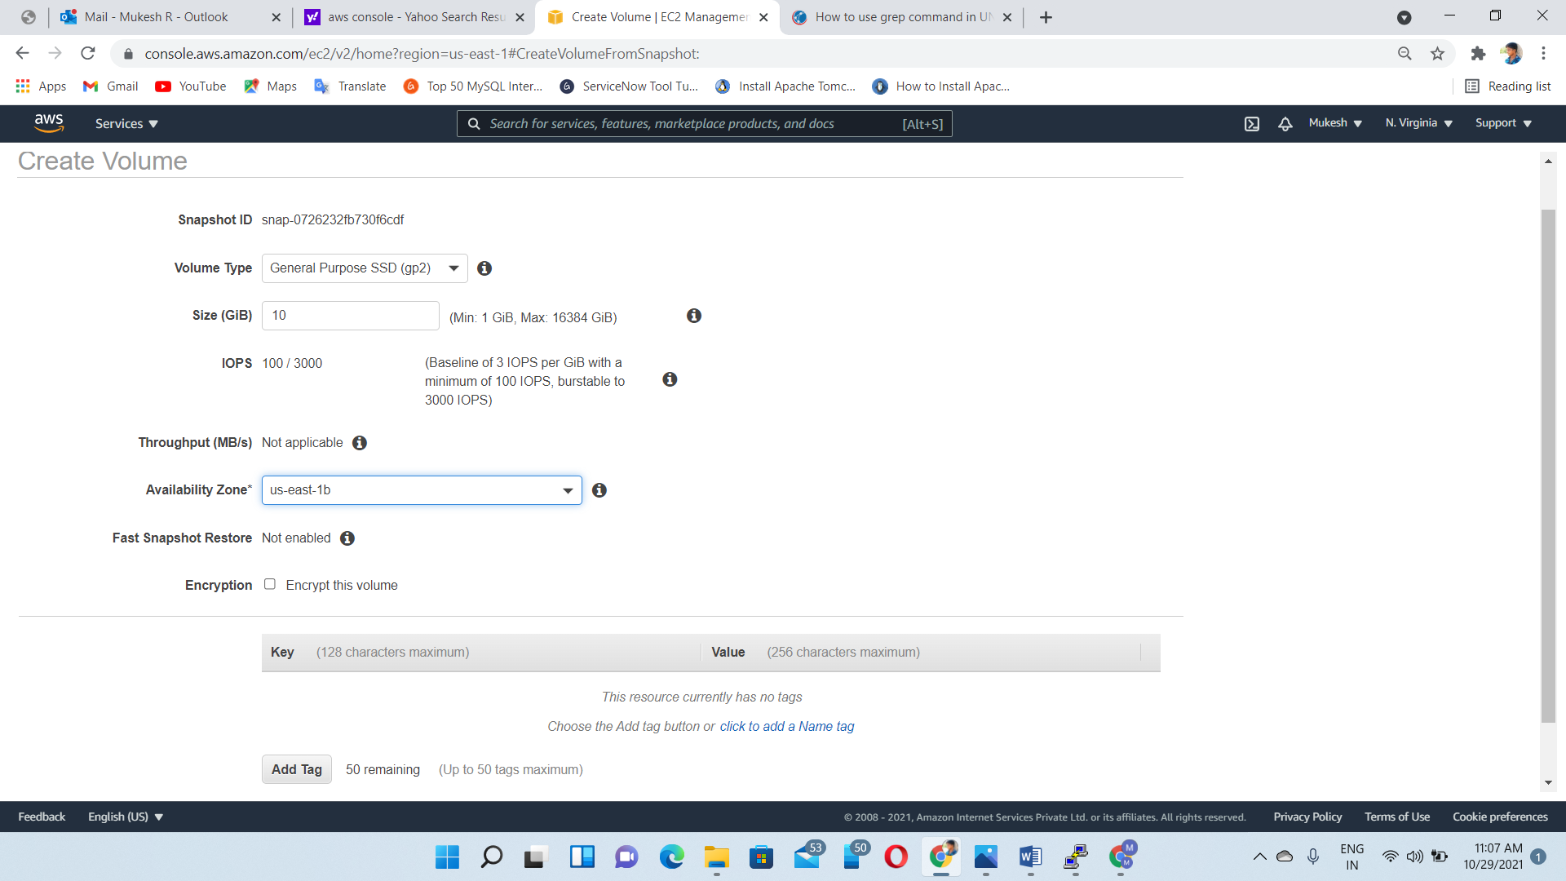

Delete the file and check whether the file is available or not

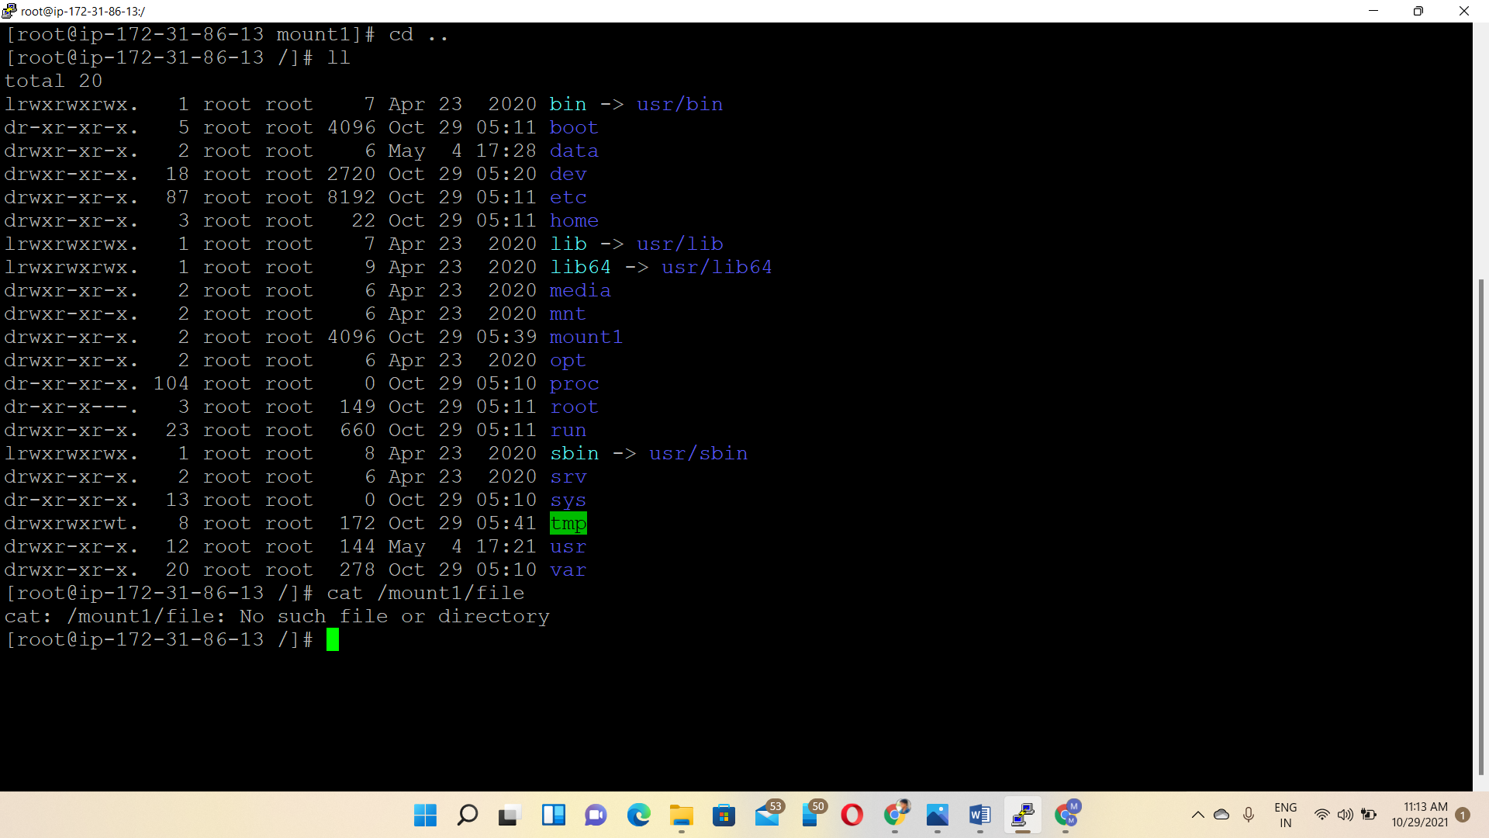

Then, we attach snapshot volume to the instance

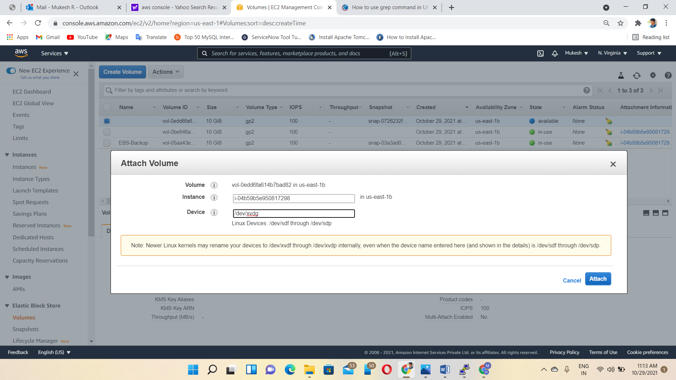

Again, check the volume blocks

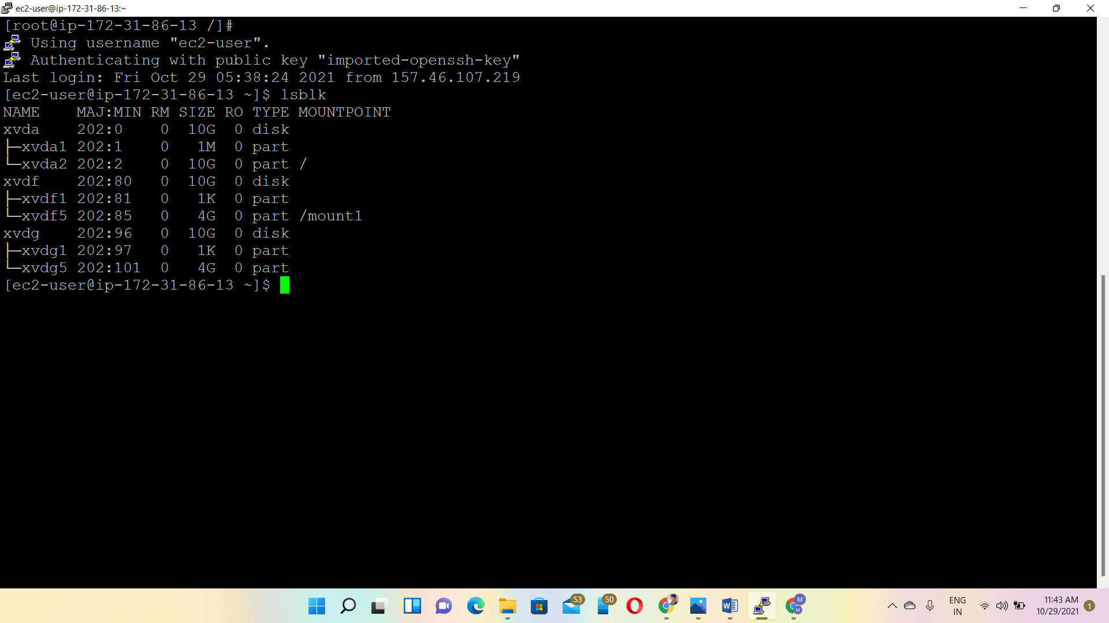

Backup the file from new volume

